Volunteer Voice
Summer 2025

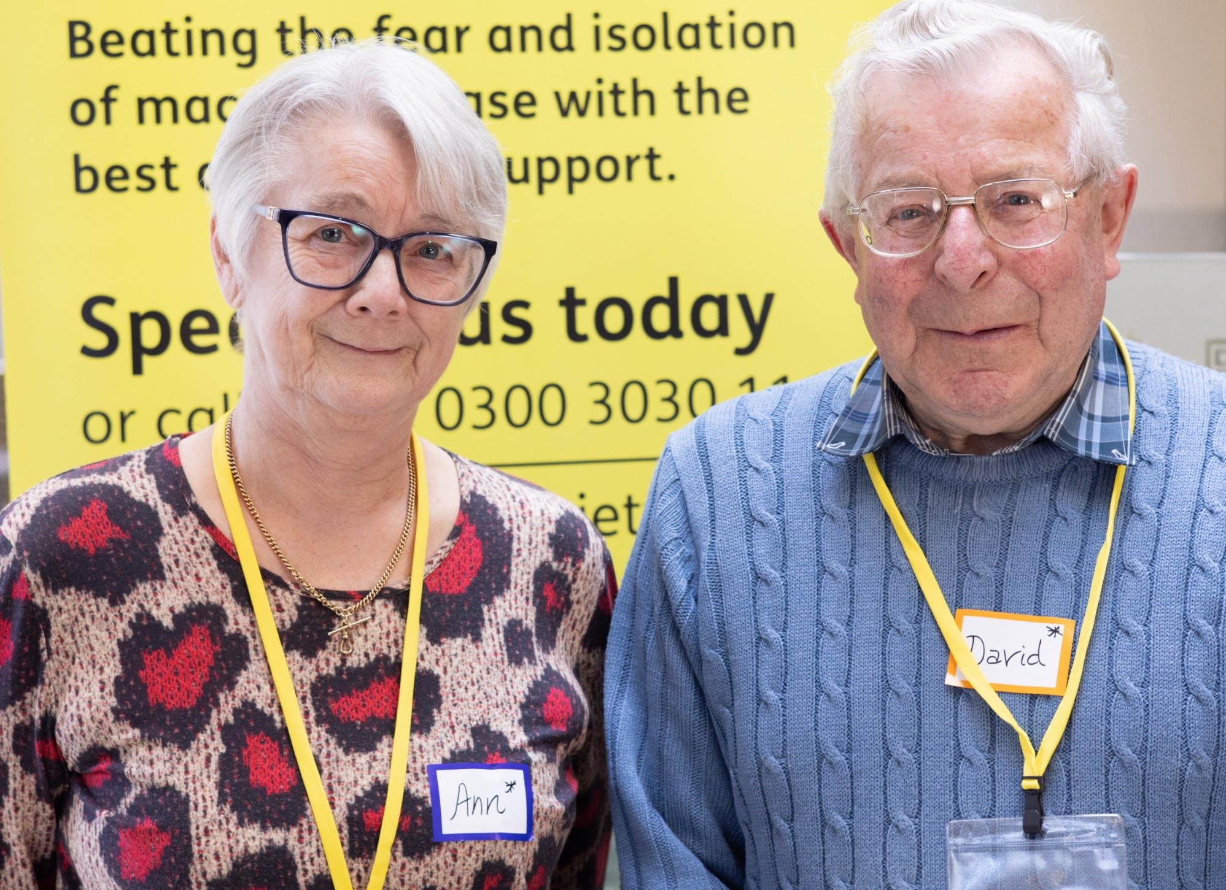

Inside this issue

- Peter’s accessible bingo game
- Northern Ireland development day
- Meet one of our trustees

Pass me on!
Please read and share with other volunteers.

Contents

Page 2 Volunteer Data
Page 3 Welcome
Page 4 A full house of support
Page 5 New group for Newstead
Pages 6-7 NI development day
Pages 8-9 A befriender in me
Page 10 Leah takes the LEAP
Page 11 Meet one of our trustees
Page 12 Remembering Betty

Your key contacts

All services and support-related enquiries:
Helpline 0300 3030 111

Regional support or contact details for your regional manager:
Groups admin 01264 560 259

Volunteering support:
Volunteer manager 01264 601 041

Befriending support:
Befriending 01264 326 622

Information about fundraising and membership:
Supporter care 01264 350 551

Facts and figures about our volunteers

(stats correct as of April 2025)

- We have 1,038 volunteers performing 1,286 roles.

- We have the most volunteers in south central England.

- If each role was a step, our volunteers would have climbed the Eiffel Tower four times.

- If each volunteer role lasted just one hour, that would be over 53 straight days of continuous volunteering.

- Our volunteers contribute almost 67,000 hours a year (if they only volunteered for 1 hour per week) - that’s nearly 7.5 years of continuous, non-stop work.

- If one person worked 24/7 without breaks, it would take them over seven years to match our volunteers’ annual contribution!

- Our volunteers provide the equivalent of 32 full-time support worker roles to ensure no one faces macular disease alone.

Welcome

Welcome to your 2025 issue of Volunteer Voice

Your annual magazine is now published to coincide with Volunteers’ Week, which celebrates and recognises the contributions of volunteers.

This year, as part of our long-term planning, and in response to rising costs, we’re reviewing how we work to ensure we continue delivering our mission in a way that best serves you and the people we support.

You may be aware that we’ve been considering some changes which could reduce the size of our regional team. These proposals are still under consultation. While this is a necessary process, one thing remains unchanged, and that is the vital role you play as a volunteer. The contribution you make is as important as ever.

As always, Volunteer Voice is about celebrating you, and this issue is no exception as we have some fantastic stories to share.

Like Peter from Fife, whose incredible efforts have brought so much success to groups in Scotland (page 4), and Leah (page 10), who has Best disease and volunteers on our new Lived Experience Advisory Panel (LEAP).

With your continued help, together we will Beat Macular Disease.

I hope you enjoy your magazine and have a splendid summer.

Ed Holloway
Chief executive

A house full of support

Before his sight loss worsened, Peter had been a passionate woodworker, creating wonderful pieces on his lathe – a hobby that sadly became more difficult as his eyesight deteriorated.

Peter, from Glenrothes in Fife, was diagnosed with wet age-related macular degeneration (AMD) and was referred to the Macular Society by Sight Scotland Veterans. Registered as severely sight impaired and with little support, he was facing loneliness and isolation.

Since joining the Kirkcaldy group, his confidence has flourished, and he has been successfully running the group for almost a year.

Remembering his love of woodwork, he wanted to contribute something meaningful to the Macular Society.

Despite no longer being able to operate a scroll saw, he crafted a large-print wooden bingo set as a gift for the support groups.

Little did he know that his creation would travel far and wide, bringing fun and laughter to many. The bingo set has been sent across the south-east of Scotland, most recently making its way to the Scottish Borders, where volunteers there have also enjoyed using it with their group members.

Bathgate group member Nan McDonald was delighted with the Bingo set that Peter crafted. She said: “It’s a travelling bag of fun and laughter that brings shared happy times to so many.”

New group for Newstead

Our Newstead group was established in October last year thanks to Amanda Gibbons, who set up the group.

Amanda has wet age-related macular degeneration (AMD) in both eyes and found it very difficult to get support.

She was struggling to find her local group as she says she lives in the middle of nowhere and, like many people with sight loss, finds it difficult getting anywhere.

Amanda explained: “I was speaking to Paul Holden (regional manager for Central Midlands), and I think we jokingly said, ‘what about starting a new group?’. We thought about where might be practical for people with sight loss and limited mobility like me.

“We settled on Newstead village, which is just down the road. So we arranged our first meeting in October 2024 and have met every month since.”

With around 12 to 14 members attending each session, it’s a small but happy group, and Amanda is enjoying her new role as a volunteer.

She said: “I thrive when I can help people. It helps to talk to and meet like-minded people – it brings us all together. The Macular Society has been a massive support to me. I want to give something back.”

Simone, who is a member of the Newstead group, said: “My daughter came across a leaflet saying a new group was starting in the area, so we went along. We really enjoyed it, and it was so informative. Amanda has been amazing, she is so lovely and kind.”

Northern Ireland volunteers come together for development day

In March, our Northern Ireland (NI) team hosted a volunteer development day in Belfast.

The event was attended by 32 volunteers, with nine of our 21 NI groups represented, along with befriending and tech volunteers.

We were also delighted to welcome our chief executive, Ed Holloway, who kicked off the day with a personal introduction and a thorough overview of Macular Society research and services.

Ed’s talk was followed by Danielle McDonagh from ForSight Ireland and Una Mulgrew of RNIB, who explained their organisations’ missions and services.

One volunteer later commented that they “so valued hearing about other related organisations and services offered”.

You asked, we actioned

This event came about following a number of requests our volunteers had made for talks on various topics, which included more hands-on IT support.

As a result, AbilityNet came along to provide IT workshops to attendees. Attendees were able to circulate between four tables which offered tips and insights on using social media, Zoom, smartphone apps, and talking texts and emails.

Following other requests, we offered two further workshop options to our volunteers.

Paula Meenan of DeafBlind gave an informative, interactive workshop on caring for people with dual sensory loss, and Christopher Conlon from BPerfect gave a make-up demonstration.

Stephen Thompson, group volunteer for the Newtownabbey group, said: “It was well structured, well organised, and the workshops were a great idea.

It was good to hear other people’s stories and get a sense of the scale of volunteering.

“Often you’re in your own bubble with your own group. It was a very positive experience and it reinforced the value of volunteering and encouraged me to continue my volunteer work and develop my role as a volunteer.”

David McKane, group leader of the Londonderry group, said: “It was great to meet others like me with the same condition. I found the tech talk by AbilityNet really helpful. The whole day was very worthwhile.”

The NI team is very grateful to our donors who made this day possible, and especially to all the wonderful volunteers who make up our support network. We couldn’t do it without you!
Your annual summer edition of Volunteer Voice will now be sent to you at the beginning of June to coincide with Volunteers’ Week.

In the past, Volunteer Voice was sometimes the only form of communication with our volunteers. However, with the recent increase in online and telecommunications with our volunteers, as well as the monthly newsletter from regional managers, we have other ways of keeping our volunteers up to date.

Despite this, we recognise the benefits of the publication and its role in keeping our volunteer community together and celebrating the work of our volunteers. That’s why we’ll still be publishing Volunteer Voice on an annual basis.

You’ve got a befriender in me

Two of our befrienders share their stories.

Audrey’s story

Audrey found out about our befriending service in Sideview magazine.

She said: “Over the years, people have said to me how good I am at listening and how supportive I’ve been. I read an article about a befriender that had 10 befriendees, and I thought, I could do that. And I did.

Audrey was matched with May last year and they hit it off straight away. Audrey said: “We’re the same sort of age, we remember the war, and we’ve formed a really big bond over that.”

She added: “I love volunteering, I find it so rewarding and like listening to other people’s stories.”

Audrey and May chat every week. “We’re in regular contact and she is a joy,” said Audrey. “We just slot in beautifully together. We have such a laugh together.”

Befriending stats

- We currently have 168 befriender volunteers supporting 244 befriendees
- An incredible 109 new matches were made last year
- On average, we receive around 150 new referrals each year
Tessa’s story

Tessa’s mother had age-related macular degeneration (AMD) and caring for her gave Tessa a great amount of sympathy for people with sight loss.

Now she has dry AMD too, volunteering seemed like a useful thing for Tessa to do.

She said: “Everyone I’ve spoken to just wants someone to talk to who understands, and often family and friends don’t understand.”

Tessa has been volunteering with us for over 13 years, as a befriender and Skills for Seeing trainer.

She’s worked with eight befriendees over the years. One of those was 102-year-old Betty.

Tessa said: “We had a lot in common. We both loved gardening. About a year ago Betty moved to a care home, and it was great that our friendship continued. I think it was nice for Betty to hear a familiar voice.”

She added: “It’s always difficult to see the decline in my matches, but I know it’s so worthwhile. It’s nice to feel I can be of some use to people.”

If you’re currently a befriender and would like to take on an additional match or learn more about the support calls available, please get in touch with the team on 01264 326 622 or email befriending@macularsociety.org

Leah takes the LEAP

Last year we set up the Lived Experience Advisory Panel (LEAP), to help shape and create services that are more sustainable, accessible and inclusive for our members.

The panel consists of 15 members, 13 of whom represent a great cross-section of the macular disease community. The other two are a friend or family member of someone living with macular disease.

Leah (pictured below), who was diagnosed with Best disease during the pandemic, decided to apply to join the LEAP as she uses co-creation in her career within education and designing courses that are accessible and inclusive.

She said: “Drawing on the experiences of people who are going to use the services is a great idea.

“I think the Macular Society is already doing a great job at providing some really important and helpful services to people like me. So, anything I can do to support that is really positive.

“It’s setting a great example for other organisations, to show them how essential lived experience is and what it can do when put at the heart of an organisation.”

Applications to become a member of the LEAP are now closed. Visit macularsociety.org/leap to find out more and for updates on when they reopen.

Interview with a trustee

Amanda Rowland talks about being a trustee of the Macular Society, a volunteer role she’s held for almost five years.

Tell us a bit about yourself.

Before retiring in 2019, I worked as a lawyer, firstly in tax and then financial services regulation.

I’ve also lived with myopic macular degeneration for many years, so I have a personal connection to the Macular Society.

How did you become a volunteer?

I saw an advert for trustees in Sideview magazine in 2020. I sent in my CV, had a phone interview, as we were in lockdown at the time, and I’ve been a trustee ever since.

What does being a trustee involve?

A critical role for trustees is setting the strategy of the charity and working with the executive staff to oversee implementation. We focus on finance, governance and risk management, supporting the team while leaving day-to-day operations to staff.

What’s the most rewarding part of volunteering?

Helping people adjust to vision loss by sharing my experiences and offering guidance is incredibly fulfilling. I often speak with individuals in my community who are newly diagnosed and unsure of what to expect.

Being able to reassure them and point them to the Macular Society’s resources is a great feeling.

What would you say to someone who’s considering volunteering?

Volunteering for a cause you believe in is incredibly rewarding. You don’t have to start as a trustee, there are many ways to help – whether that’s through fundraising, befriending or supporting events.

Want to become a trustee of the Macular Society?

Find out more at macularsociety.org/become-a-trustee

Remembering Betty

This October will be the 10th anniversary of the Milford Haven group, which is the legacy of Betty Wheeler, who passed away in 2023.

Betty was the original group leader for the group – from 2015 when the group was established, up until 2021, when she stepped down due to ill health.

Madeline Roberts, who took over from Betty as group leader, said: “Betty was an absolute character. She was determined not to let her sight loss affect her and carried on with her crafts – knitting scarves and blankets to be sent to Africa.

“She used to say to me there are other people worse off than us, so we’ve just got to get on with what we’ve got.

“Now I carry Betty’s voice in my head, and always ask myself, how would Betty deal with this? What would Betty do?

“If it wasn’t for Betty pushing me, I wouldn’t have become a volunteer. She pulled me out of a dark place to be involved in the group.

“She believed that the group helped people and wanted it to continue to help people after she was gone.

“I’ve tried to carry on Betty’s ethos in that we have a safe space to share experiences, fears and frustrations with the emotional rollercoaster of grief you go through with sight loss, but with a big emphasis on what we’re still able to do.”

You can find your local support group at macularsociety.org/groups

ENDS

