Volunteer Voice
Winter 2024

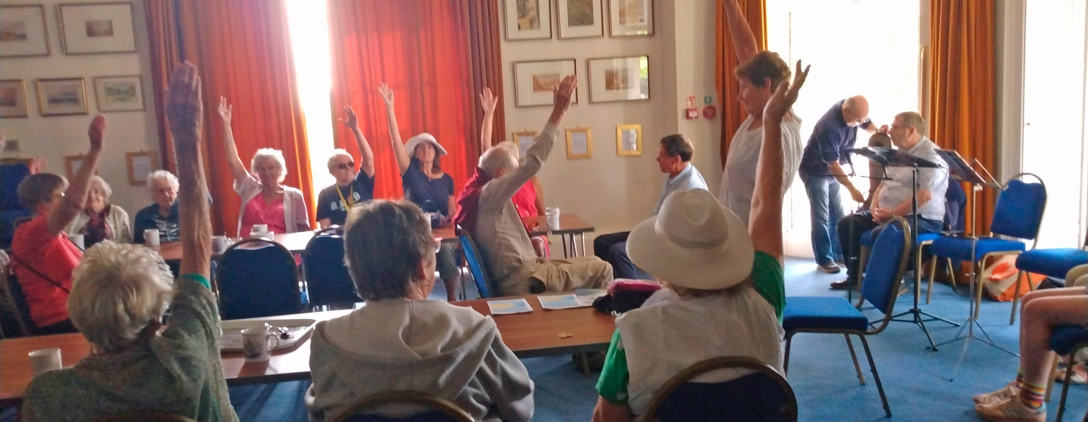

Members of the Teignmouth group take part in some armchair exercises.

Firstly, I’d like to thank you all for the warm welcome you’ve given me since I joined the Macular Society as chief executive.

I know I have some big shoes to fill after Cathy’s leadership over the last decade. It’s an honour to have the opportunity to build on her legacy, and I’m fully behind the organisation’s ambition.

Since joining the Macular Society, one thing that has really struck me is the difference our volunteers make to people affected by macular disease.

In my short time here, I’ve been inundated with stories of how you continue to go above and beyond in your volunteer roles to help our communities, and I’m proud to share some of those stories in this issue.

Volunteers are the lifeblood of our organisation and contribute so much to our successes. So thank you to each and every one of you. With your continued help, together we will Beat Macular Disease.

I hope you enjoy this issue and have a restful winter.

Ed Holloway
Chief Executive

Pass me on!
Please read and share with other volunteers.

Over to you . . .

Across the UK, dedicated volunteers like you are going the extra mile to keep our support groups strong. Here are some great examples you’ve shared.

Teignmouth thrives under new leadership

Our Teignmouth group has been revived thanks to group leader Peter Taylor.

Peter was diagnosed with Stargardts at the age of four. After a very full working life and no significant contact with other VIPs, Peter, now 71, wanted to share his knowledge of assistive technology with other macular disease sufferers.

Helped by our south-west regional manager Jo Fishwick, the Teignmouth group is flourishing.

Staff and volunteers from a local community centre recently treated the group to a morning of armchair exercises, followed by a sing-along with their own band, the Six Teigns.

One group member said: “I look forward to going to the group and meeting people in the same position as me. Peter is wonderful. I’m very impressed with what he does.”

Jo Fishwick added: “When Peter agreed to lead the group, I was delighted. He has embraced the challenges and the group has grown substantially. He’s friendly and approachable and really cares about the group and its members.”

New group launches in Frinton

We have a new group in Frinton-on-Sea. Having been a member of the Milton Keynes group, Diana Fitchett was keen to do something when she moved to Frinton, and was put in touch with regional manager, Sue Drew.

The first meeting, held in July, had a great turnout thanks to Diana promoting the group in the local area. The group has now moved to one of the meeting rooms at their venue, having reached capacity in the café area.

Local sight loss charity Essex Sight is supporting the group, and a representative attends the meetings to discuss local services for VIPs.

Group member Irene said: “I hadn’t met anyone with AMD before I came to the first meeting, despite being told it was very common. I’ve learnt so much already and will certainly attend future meetings.”

Alf White, who is new to the area, said: “The only people who think about people living with sight loss are others who are also living with it. The support is so important.”

New group venue for Neath

Following the uncertain future of the Neath group due to costs, we’re delighted that they’ve been able to secure a new venue.

Neath group volunteer Caroline Parry helped group leader Carol find a new venue at the local library, much to the delight of the group, who were desperate to keep it going.

The new venue costs half the price of the previous one and the group can meet for longer in a more spacious room.

Senior regional manager Adele Francis said: “Caroline is a wonderful liaison volunteer between group leader Carol and myself, as Carol’s eyesight is very poor.

“It’s simply magical how supportive the groups are and highlights the diverse relationships that form from them.”
Befriending is a two way street

Our befriending service continues to be in high demand. We currently have 179 incredible volunteers supporting 252 befriendees.

The weekly phone calls from befrienders offer so much to the people receiving them – from a light-hearted chat to sharing some of the challenges that come with navigating sight loss.

A friendly voice

Veronica has been volunteering as a befriender for the last year and recently received her bronze award for volunteering.

She said: “I suffer from sight loss myself, but I’m fortunate because I have family and support at home. I know a lot of people don’t have that, and it can be lonely.

“I realised so many people would be glad to hear a friendly voice on the phone, and I wanted to help and make sure that some good came from losing my sight.

“Through being a befriending volunteer, I’ve made two very good friends myself. It really does go beyond just being a voice on the other end of the phone. I can support others, but it helps my personal journey too. It’s a two-way street. I think it’s a wonderful service, and the role is so rewarding.”

Well supported

Befriendee Jennifer has been receiving befriending calls from Veronica since April. She said: “Veronica calls me every Thursday. We both have the same eye problems, so we can support each other, moan about our dry eyes, chat, and have a giggle.

“I always look forward to speaking to her and missed her when she was away on holiday! The calls help me to feel less alone, and it’s great to talk to someone who understands. I get to know about her family and she knows about mine. I feel well-supported.”

The befriending team offers support calls every other month for befriending volunteers to join. We recommend befrienders join a couple a year to get service updates, peer support and a chance to share good news stories or discuss challenging conversations. We always love to hear from our befrienders with call updates.

If you’re currently a befriender and would like to take on an additional match or learn more about the support calls available, please get in touch with the team on 01264 326 622 or email befriending@macularsociety.org

Tech volunteers making a difference

Our volunteer roles offer invaluable peer support. And this is especially true of our Skills for Seeing and Connect by Tech volunteers.

They offer practical support that makes a huge difference to people in maintaining their independence and increasing their confidence.

Making the most of technology

In 2023, both services combined helped almost 600 people, through information on lighting and low vision aids, teaching eccentric viewing techniques and making the most of technology.

While we’re no longer recruiting for the Skills for Seeing volunteer role, we want to say a huge thank you to our existing volunteers who still support a large number of people every year.

Part of our Skills for Seeing service now incorporates Connect by Tech, which was initially set up in 2020 to help people stay connected during lockdown.

Providing support

We’re always looking for additional volunteers with tech know-how to help people maximise their existing tech products.

Sheila Harris has volunteered for the service since its inception. She said: “It’s opened my eyes to the fact that older people can use tech, even though so many people write them off. I’ve taught people from working age to 92 and everyone has got something out of it.”

If you’d like to offer your skills to the Connect by Tech service or want to know more about the practical support available, please contact the team on 01264 601 363 or email techtalk@macularsociety.org

Have you completed your data protection training?

A massive thank you to all volunteers who’ve completed the data protection training via Zoom.

Depending on your volunteer role, you’ll have received an email to sign up for the training. It lasts for an hour and there are multiple sessions available, so you can choose one to suit your schedule.

If you’ve received an email but have not yet signed up for the training, please do so as soon as possible. If you’re unable to join via Zoom, you can be dialled into the sessions using your phone number.

For more information on how to do this, or if you have any questions related to the training, please either contact your manager or email the volunteer manager, Aaishah Khan: Aaishah.khan@macularsociety.org

Volunteer Voice update

From 2025, Volunteer Voice will be published once a year instead of twice a year.

Don’t worry, you’ll still receive the publication in your chosen format.

Your annual summer edition of Volunteer Voice will now be sent to you at the beginning of June to coincide with Volunteers’ Week.

In the past, Volunteer Voice was sometimes the only form of communication with our volunteers. However, with the recent increase in online and telecommunications with our volunteers, as well as the monthly newsletter from regional managers, we have other ways of keeping our volunteers up to date.

Despite this, we recognise the benefits of the publication and its role in keeping our volunteer community together and celebrating the work of our volunteers. That’s why we’ll still be publishing Volunteer Voice on an annual basis.

Support for you

Making the most of your Macular Society volunteering

From role-specific development and training to updates and refreshers, we run volunteer sessions across the UK and encourage you to attend. These are a great way to get together with fellow volunteers to ask questions, share experiences and make new friends.

“I learn something new every time and it’s reassuring to know that I am doing things right. The hints and tips are a good way to learn and share with others.” Caroline, Skills for Seeing Volunteer

Please contact your volunteer manager for details of upcoming sessions.

Your key contacts

- For all services and support-related enquiries:
Helpline 0300 3030 111:
- For regional support or contact details for your regional manager: Groups admin 01264 560 259
- For volunteering support:
Volunteer manager 01264 601 041
- For befriending queries:
Befriending 01264 326 622
- For information about fundraising and membership:
Supporter Care 01264 350 551

Have you received this in the correct format?
To change your preference or if you no longer wish to receive Volunteer Voice from us, please visit macularsociety.org/vvpreference.

Macular Society is the trading name of the Macular Disease Society. A charity registered in England and Wales 1001198, Scotland SC042015 and Isle of Man 1123. A company limited by guarantee, registered in England No. 2177039. Registered Office: Macular Society, Crown Chambers, South Street, Andover SP10 2BN.

Registered with the FUNDRAISING REGULATOR.

ENDS

